AMENDMENT NUMBER [1]

The Performance Contract (Contract) executed [April 28 ,2023] by Momentum Academy (School) and the Missouri Charter Public School Commission (Commission) is amended as follows, effective on the date of execution by both parties.

Implementation

MA may enroll students up to the enrollment projections included in Exhibit 3.

Exhibits

8. MA Projected Enrollment for Renewal Term below.

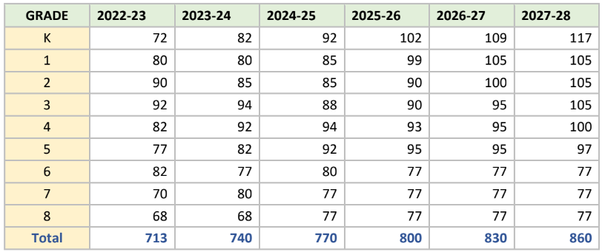

Exhibit 8 of the [Performance Contract or Charter Application (incorporated by reference into the Performance Contract)] is amended as follows:

[Enrollment plan and projections adjusted to further realistically align with enrollment trends and transition of one campus from K-8 to K-5 in FY 25 thru FY28.]

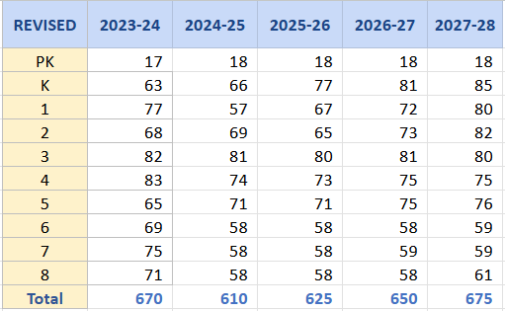

MOMENTUM ACADEMY remains accountable to the goals from FY24 through FYXX as written in the JULY 2023 Application/Renewal and Performance Contract. MOMENTUM ACADEMY’S performance across all years of that contract will be considered by the Commission when making renewal or other sponsorship decisions.

All other terms of the Performance Contract, including prior amendments, remain effective as written.

IN WITNESS WHEREOF, the parties hereto have executed this Amendment.
By: _____________________________ By: _______________________________
Name: Robbyn G. Wahby DAVID SIMMONS, Board Chair
Executive Director MOMENTUM ACDEMY
Missouri Charter Public School Commission
Date: ____________________________ Date: ______________________________

